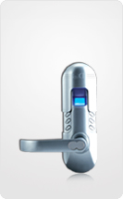 |   

Serrure à empreintes digitales DIGI 6600-98

Serrure autonome à empreintes digitales et codes pour Contrôle d’accès. Jusqu’à 150 empreintes et 78 codes. Possibilité de programmer les horaires d’accès autorisés pour chaque utilisateur. Ouverture par clefs possible.
Convient pour habitations et Bureaux.
Pure stainless steel mechanical rotating structure enables its life to be more than 10 years.
It is very easy to change batteries in the lock, just need several minutes on one lock.

Using 4 x1.5V standard alkaline batteries.

Unlock ways: Fingerprint keypad or Mechanical key.

The fired users can be deleted individually without any effect on the application of the other users

Can delete the users individually who were fired. But there is no effect for the other people to use.

Use 9V extra power when power is off, which is safe and convenient.

