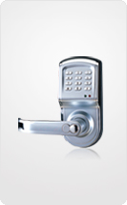 |   

Serrure à codes DIGI 6600-88

Serrure autonome à codes pour Contrôle d’accès. Jusqu’à 300 utilisateurs. Possibilité de programmer les horaires d’accès autorisés pour chaque utilisateur.
Convient pour habitations et Bureaux.
Pure stainless steel mechanical rotating structure enables its life to be more than 10 years.
It is very easy to change batteries in the lock, just need several minutes on one lock.

Using 4 x1.5V standard alkaline batteries.

If wrong passwords are put for 3 times continuously, it will stop for 10 seconds automatically.

Unlock ways: keypad or Mechanical key.

Can delete the users individually who were fired. But there is no effect for the other people to use.

Keypad user capacity 300.

It can set up available time for each user to unlock the lock. And the user can not unlock it in other time..

